

|  |  |
| --- | --- |
| **Network & Security ADMIN** | Secure CI/CD Azure Arc Cloudflare  Tunnels  **ADMIN Network & Security**  **Issue 77** |

[Secure CI/CD](https://www.admin-magazine.com)   
 [Pipelines Best practices for better DevOps security](https://www.admin-magazine.com)

[Ansible Container Management](https://www.admin-magazine.com)

[Monit:](https://www.admin-magazine.com)**[Proactive healing](https://www.admin-magazine.com)**   
**[for *nix servers](https://www.admin-magazine.com)**

[Azure Arc:](https://www.admin-magazine.com)**[Multicloud on-premises](https://www.admin-magazine.com)**   
**[management platform](https://www.admin-magazine.com)**

[What’s New in Ceph](https://www.admin-magazine.com)

[GENEVE Tunneling Protocol](https://www.admin-magazine.com)   
**[Improved flexibility and scalability](https://www.admin-magazine.com)**

|  |  |
| --- | --- |
| BeagleV-Ahead RISC-V CPU **Latest SBC in the**  **BeagleBone family** | Cloudflare Tunnels  **VPN alternative for secure server access** |

|  |  |
| --- | --- |
| Fluentd and Fluent Bit **Unified log collection** | MikroTik:**Affordable routers with professional powers** |

**[w w w . a d m i n - m a g a z i n e . c o m](https://www.admin-magazine.com)**

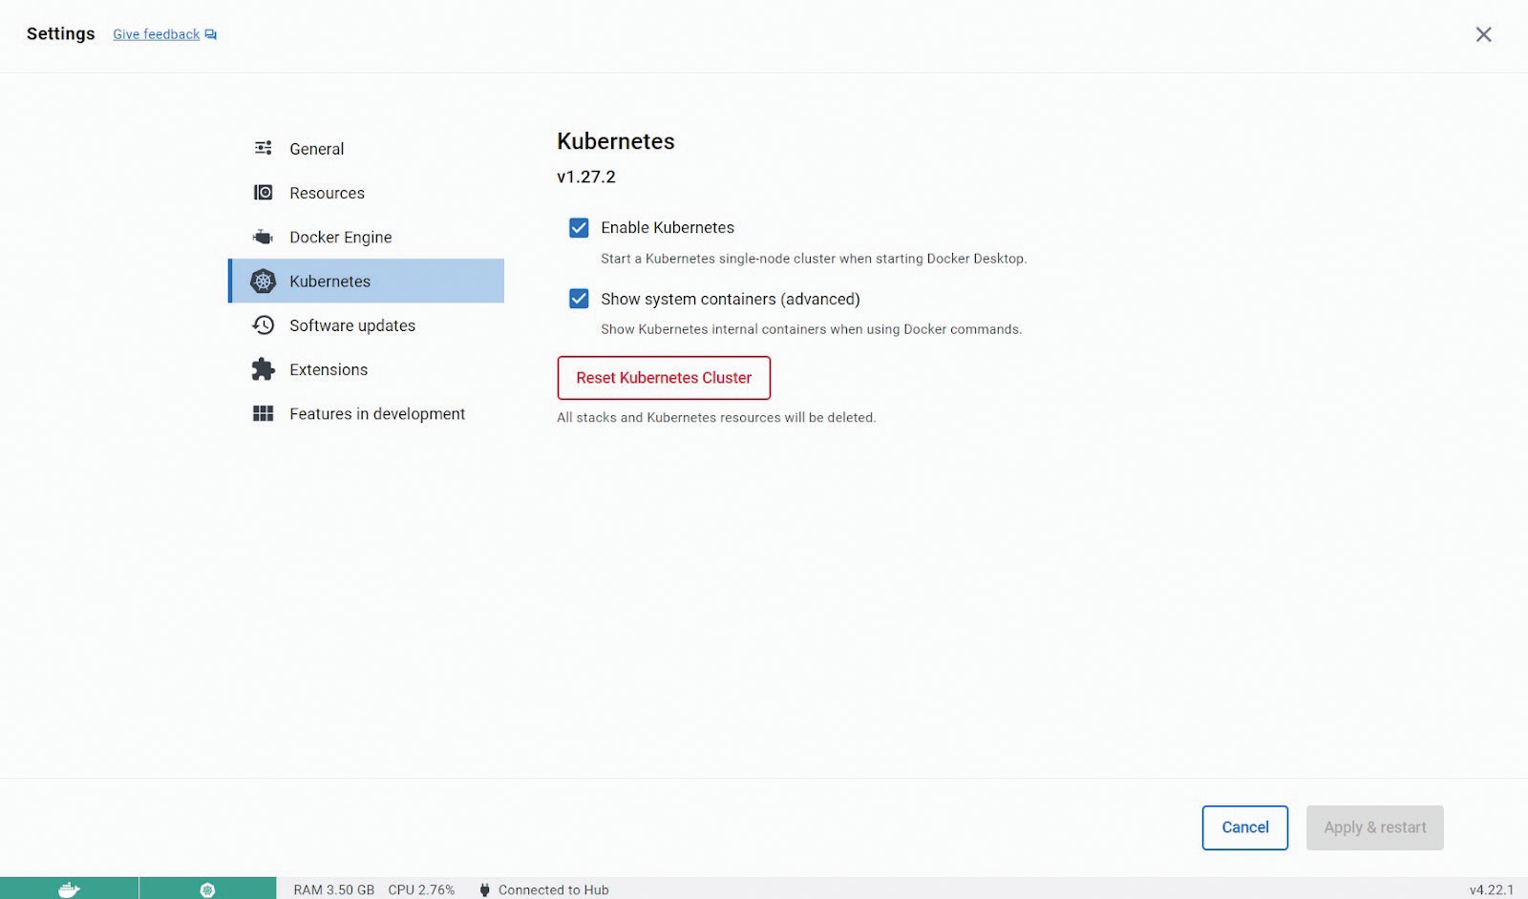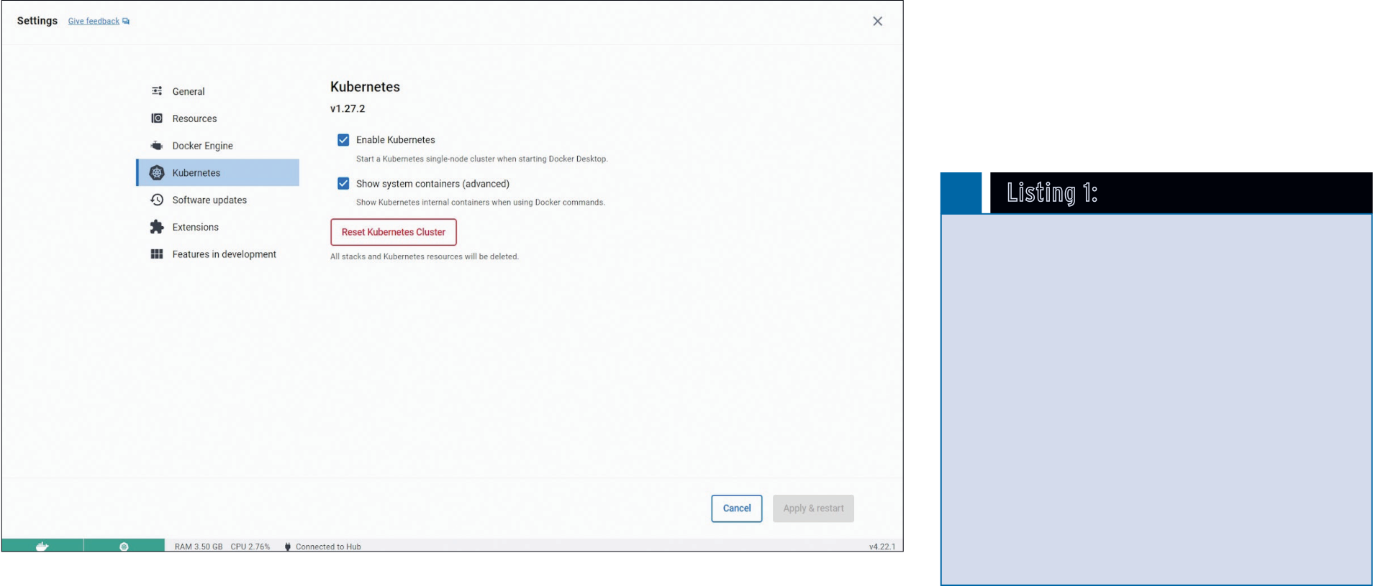

Tools Docker Desktop Local Cluster

**Test your containers with the**   
**Docker Desktop one-node cluster**  
 Test Lab

The built-in single-node Kubernetes cluster included with Docker

Desktop is a handy tool for testing your container. By Artur Skura

|  |  |  |
| --- | --- | --- |
| **Docker makes it easy** for developers | and corresponding libraries – and then | of just one container. If you have |
| to deploy applications and ensure that | because of a tiny glitch in the docs, | more than one container, you need |
| the local development environment | things didn’t work as expected? | a way to organize them that is trans- |
| is reasonably close to the staging and | Thanks to Docker, these days are | parent to your users. In other words, |
| production environments. Remember | mostly over. You can develop your | you need a container orchestration |
| the times you found a great app only | app and test it locally and then | platform. The unquestioned leader in |
| to discover the installation instructions | deploy it to the testing and produc- | orchestration is Kubernetes (K8s for |
| extended over several pages and in- | tion environments with few or no | short). It is easy to get started with |
| volved configuring the database, popu- | changes. But Docker itself is not | Kubernetes if you have Docker Desk- |
| lating tables, installing many packages | enough. Modern apps rarely consist | top installed. Simply go to *Settings |* |

*Kubernetes* and select *Enable Kuber-*  
*netes* (Figure 1). Enabling Kubernetes   
from Docker Desktop gets you a one-  
node cluster suitable for local testing   
and experiments.

Listing 1: my-app/​nginx/​nginx.conf

01 events {   
02 worker_connections 1024;   
03 }

|  |  |  |  |
| --- | --- | --- | --- |
| 2 | **Figure 1: Enabling Kubernetes in Docker Desktop.** | 04 http { | **Photo by Alex Kondratiev on Unsplash** |
| 05 server { |
| 06 listen 80; |
| 07 location / { |
| 08 proxy_pass http://webapp:5000; |
| 09 } |
| 10 } |
| 11 } |
| ADMIN 77 | [www.admin-magazine.com](https://www.admin-magazine.com) |



|  |  |  |  |
| --- | --- | --- | --- |
| Single-node clusters are quite useful | Docker Desktop Local Cluster | | Tools |
| Kubernetes is a complex beast, and it | Kubernetes cluster. I will create a |

|  |  |  |  |
| --- | --- | --- | --- |
| for testing, and the single-node Ku- | might be confusing to present its archi- | docker‑compose.yml file that sets up | |
| bernetes cluster bundled with Docker | tecture in detail, so I’ll focus on the es- | a web application stack consisting | |
| Desktop is pre-configured and ready | sentials. For starters, it’s enough to re- | of an Nginx reverse proxy, a Python | |
| to use. Along with this single-node | member two concepts: nodes and pods. | Flask web application, and a Redis | |
| cluster (called “Kubernetes server” in | Nodes normally correspond to virtual | database. In the root directory of your | |
| Docker docs), Docker Desktop also | (or, less often, bare metal) machines on | project (let’s call it my‑app), create | |
| includes the kubectl command-line | which pods are running. Pods, on the | Listing 2: my-app/​nginx/​Dockerfile | |
| tool (called “Kubernetes client”). | other hand, correspond to sets of con- |
| Because kubectl is already set up to | tainers, and they are running in nodes. | 01 FROM nginx:alpine | |
| work with the cluster, you can start | One node can contain several pods. | 02 COPY nginx.conf /etc/nginx/nginx.conf | |
| issuing commands straight away | One pod cannot run on more than one | Listing 3: my-app/​webapp/​app.py | |
| without additional configuration. | node – instead, you create replicas of |
| **About Kubernetes** | the pod using so-called *deployments*. | 01 from flask import Flask | |
| A typical Kubernetes cluster has several | 02 import redis | |
| nodes with one or more pods running | 03 import os | |
| Many people say they would like to | on each node. When one node fails, | 04 | |
| start learning Kubernetes, but they | the pods that had been running on it | 05 app = Flask(__name__) | |
| somehow get stuck at the first phase, | are considered lost and are scheduled | 06 redis_host = os.getenv("REDIS_HOST", "localhost") | |
| that is, the installation. The problem | by the cluster to run on other, healthy | 07 r = redis.Redis(host=redis_host, port=6379, decode_ | |
| is, administering a Kubernetes cluster | nodes. All this happens automatically | responses=True) | |
| and developing software that runs on | when you use a deployment. Kuber- | 08 | |
| it are two different tasks that are often | netes is therefore a self-healing plat- | 09 @app.route('/') | |
| handled by different teams. Installing, | form for running containerized apps. | 10 def hello(): | |
| upgrading, and managing the cluster | Even on the basis of this simplified | 11 count = r.incr('counter') | |
| is usually done by the Ops or DevOps | description, you can understand why | 12 return f'Hello, you have visited {count} times.' | |
| team, whereas the development is | Kubernetes took the world by storm. | 13 | |
| 14 if __name__ == '__main__': | |
| usually done by developers. Using a | **A Multi-Container Example** |
| 15 app.run(host="0.0.0.0", port=5000) | |
| single-node cluster, developers can |
| take the first steps with verifying that |
| the containerized application works in | A simple example will show how easy | Listing 4: my-app/​webapp/​Dockerfile | |
| Kubernetes before passing it on to Ops | it is to test your Docker containers | 01 FROM python:3.11 | |
| for further implementation. | using Docker Desktop’s single-node | 02 WORKDIR /app | |
| 03 COPY . . | |
| Do I Need cri-dockerd? |
| 04 RUN pip install Flask redis | |
| features and support for extensions. Because |
| 05 CMD ["python", "app.py"] | |
| Kubernetes was built around the Docker |
| Engine container runtime, and the early ver- | Docker Engine was developed before CRI, it | Listing 5: my-app/​docker-compose.yml | |
| sions of Kubernetes were fully compatible | does not fit directly with the CRI interface. |
| with Docker Engine. Docker Engine is a full- | Kubernetes implemented a temporary adapter | 01 services: | |
| featured runtime with many features for sup- | called dockershim to support Docker Engine | 02 nginx: | |
| 03 build: ./nginx | |
| porting end users and developers – and even a | on CRI-based Kubernetes installations. Dock- |
| 04 ports: | |
| system for integrating third-party extensions. | ershim was deprecated in Kubernetes 1.20 and |
| 05 ‑ "8080:80" | |
| In many cases, developers don’t need all the | removed in version 1.24. |
| 06 depends_on: | |
| functionality provided by Docker Engine and | A new adapter called cri-dockerd now |
| 07 ‑ webapp | |
| just want a much simpler runtime. Kubernetes | provides “fully conformant compatibility | 08 webapp: | |
| implemented the Container Runtime interface | between Docker Engine and the Kubernetes | 09 build: ./webapp | |
| (CRI) in 2016 as a universal interface to sup- | system.” If you are running Kubernetes 1.24 | 10 environment: | |
| port other container runtimes. Docker contrib- | or newer with containerd, you won’t have | 11 ‑ REDIS_HOST=redis | |
| 12 depends_on: | |
| uted the code for a simpler, more elementary | to worry about compatibility. However, if |
| 13 ‑ redis | |
| container runtime called containerd, which | you want to continue to use the Docker |
| 14 redis: | |
| is compatible with CRI. Containerd is now | Engine runtime, you might have to replace |
| 15 image: "redis:alpine" | |
| maintained by the Cloud Native Computing | dockershim with the cri-dockerd adapter. Cri- |
| 16 volumes: | |
| Foundation. | dockerd is included with Docker Desktop, so | 17 ‑ redis‑data:/data | |
| Containerd works for many common scenarios | you won’t need to worry about cri-dockerd to | 18 | |
| today, but some users still prefer the more | access Docker Desktop’s single-node Kuber- | 19 volumes: | |
| robust Docker Engine, with its user interface | netes cluster. | 20 redis‑data: | |
| [www.admin-magazine.com](https://www.admin-magazine.com) | ADMIN 77 | 3 |



Tools Docker Desktop Local Cluster

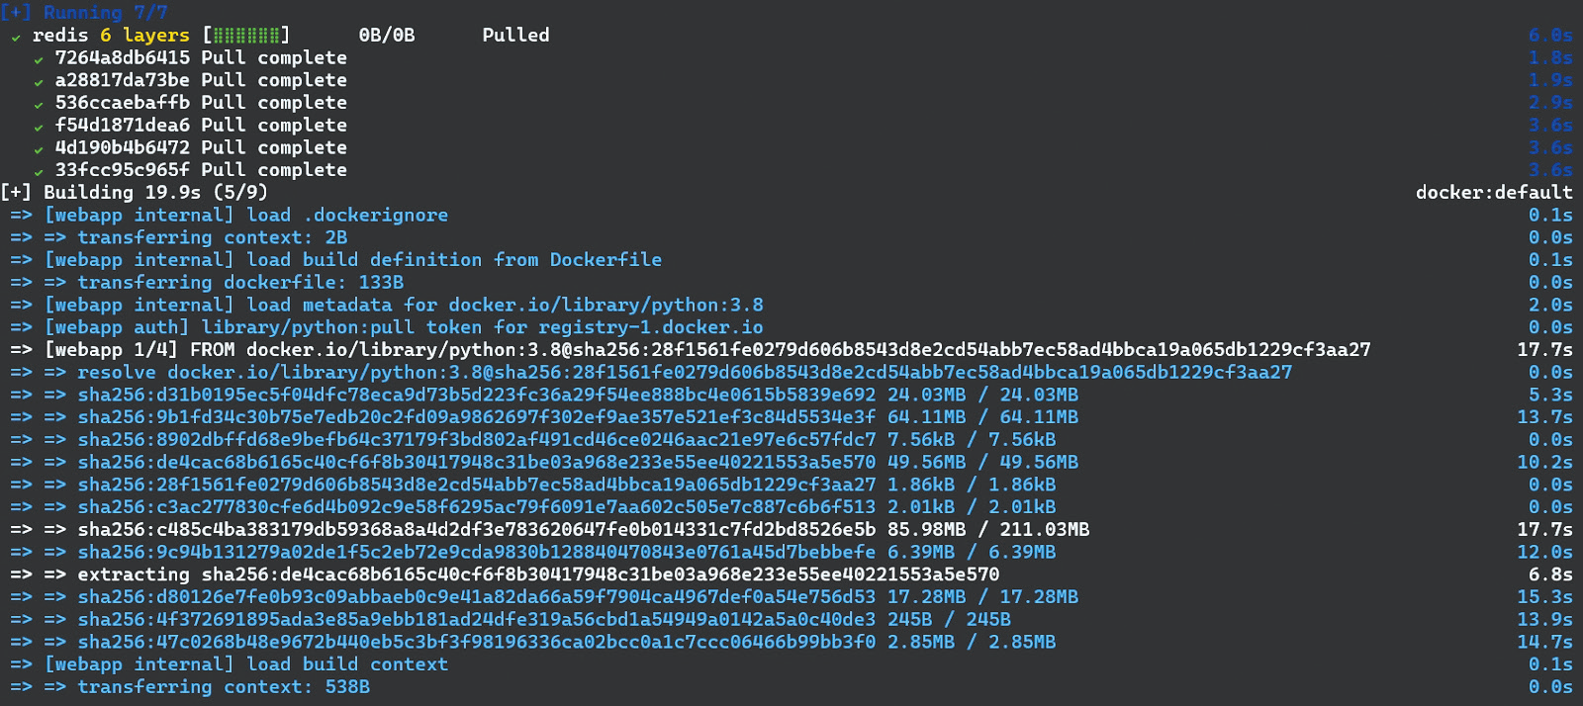

**Figure 2: Building images with Docker Compose.**

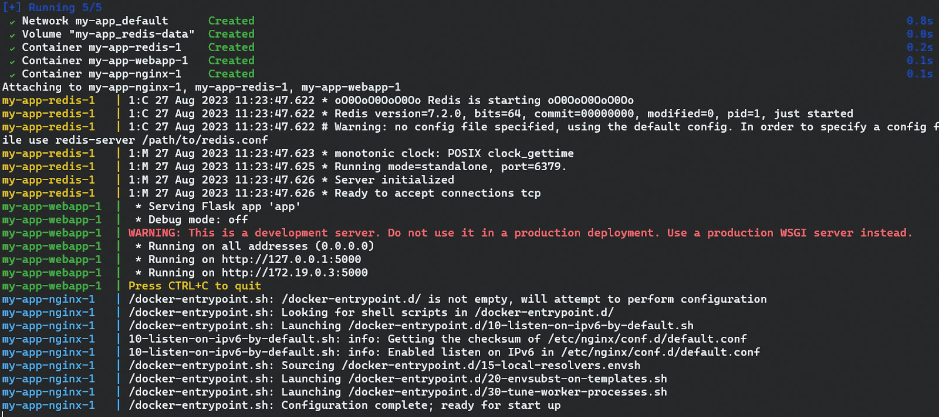

**Figure 3: Running containers with Docker Compose.**

|  |  |  |
| --- | --- | --- |
| two folders: nginx and webapp. The | (Listing 5). It defines three services | with the image directive. Docker Com- |
| nginx directory will contain a Nginx | and one volume. You might ask why | pose makes it easy to start and build |
| configuration file nginx.conf (Listing 1) | three services since we only prepared | the whole infrastructure: |
| with a Dockerfile (Listing 2); the | two Dockerfiles? The two Docker- | docker compose up ‑‑build |
| webapp directory will contain a Flask | files are custom images, whereas |
| app app.py (Listing 3) and the cor- | the Redis image is a standard image | This command will first build the three |
| responding Dockerfile (Listing 4). In | (redis:alpine) without any modifica- |
| this way, I will build two images: one | tions, so you don’t even need to create | Docker images (Figure 2) and then run |
| containing the Flask app and another | a Dockerfile for it – you can instead | the resulting containers (Figure 3) in |
| with Nginx. The user will connect to | use the ready-made image directly | the correct order: As you will notice in |

a Nginx instance, which will commu-nicate with the Flask app. The app, in turn, will use the Redis in-memory storage tool as a simple store for   
counting users’ visits.

The key part that glues everything together is the docker‑compose.yml file

|  |
| --- |
|  |

**Figure 4: The Flask app correctly counting user visits.**

|  |  |  |
| --- | --- | --- |
| 4 | ADMIN 77 | [www.admin-magazine.com](https://www.admin-magazine.com) |

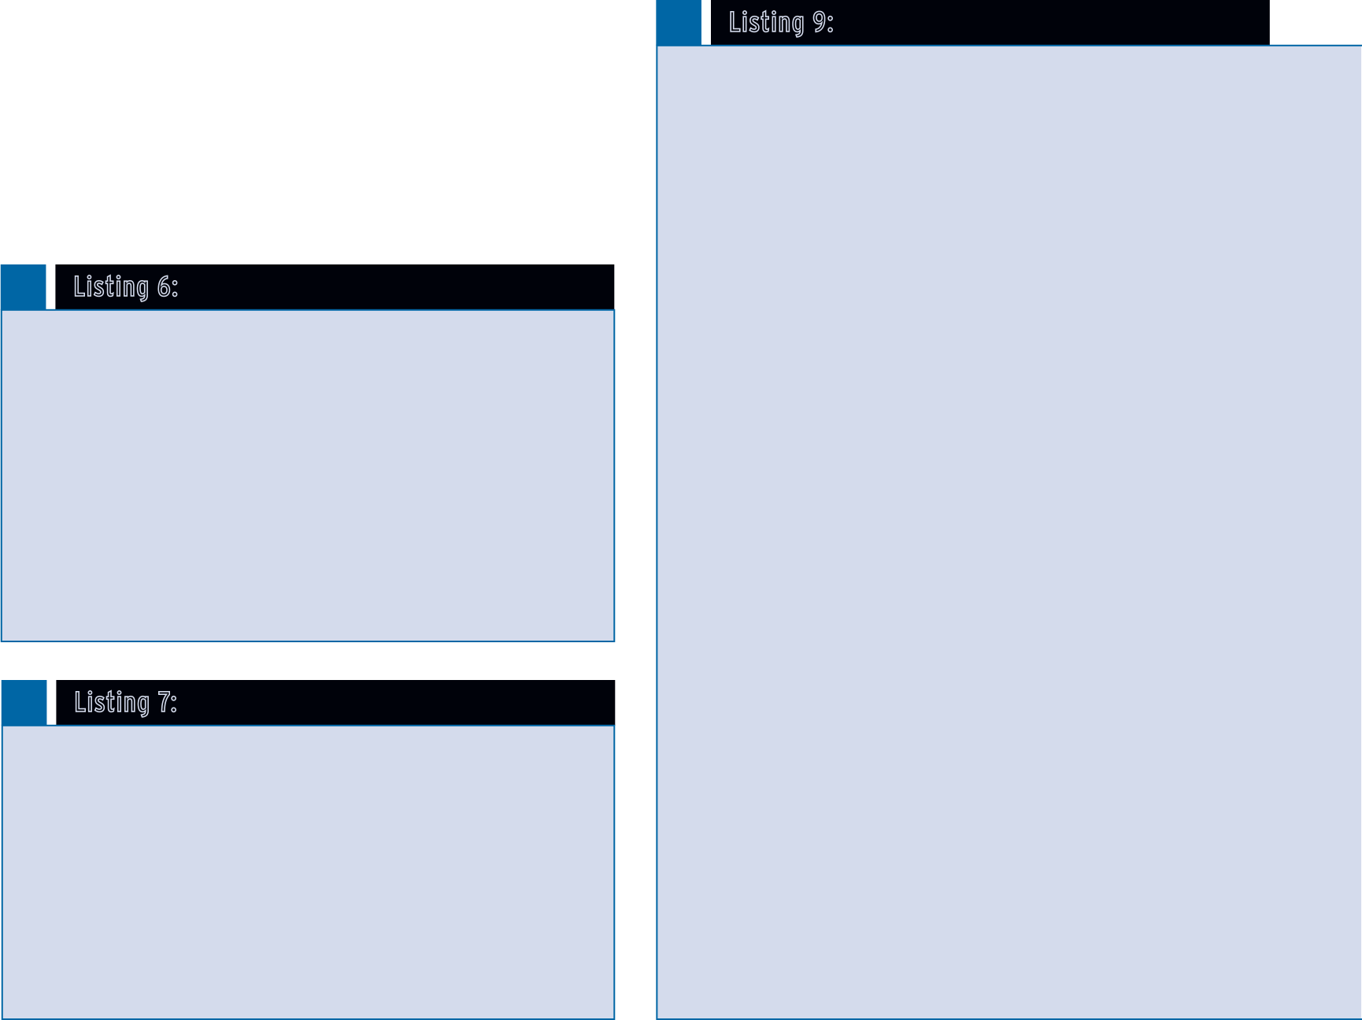

|  |  |  |
| --- | --- | --- |
| docker‑compose.yml, the redis service, | ConfigMap resource for Nginx (List- | of the actual Nginx container. This |

|  |  |  |
| --- | --- | --- |
| even though defined last, needs to | ing 12). Deployments define, among | approach has many advantages. For |
| run first because webapp depends on it, | other things, what containers and | example, I can reconfigure Nginx |
| whereas nginx has to start last because | volumes should run and how many | dynamically, and Kubernetes will |
| it depends on webapp already running. | of replicas should be created. A | Listing 8: my‑k8s‑app/redis‑service.yaml |
| The Flask app should be available on | ConfigMap is another type of re- |
| localhost:8080 and working as intended | source used for configuration. | 01 apiVersion: v1 |
| (Figure 4). (By the way, you might no- | Kubernetes will not build images. | 02 kind: Service |
| tice that I am using docker compose, a | You need to have them already built | 03 metadata: |
| new command integrated with Docker | and pass them to deployments as | 04 name: redis |
| Desktop, called Compose V2, instead | arguments of the image directive. In | 05 spec: |
| of the legacy Compose V1 command | the case of Redis, I am not modify- | 06 ports: |
| docker‑compose. Unless you have a good | ing the official image and can use it | 07 ‑ port: 6379 |
| 08 selector: |
| reason to use V1, you should always | directly. |
| 09 app: redis |
| use V2 as V1 is not receiving updates.) | With Nginx, things get a bit more |
| As a side note, if you are planning on | complex because I need to adapt | Listing 9: my-k8s-app/​ nginx-deployment.yaml |
| using the Docker Engine runtime with | the default configuration. Fortu- |
| Kubernetes, see the sidebar entitled | nately, I don’t have to modify the | 01 apiVersion: apps/v1 |

“Do I Need cri-dockerd?” image this time and can use another Kubernetes resource: ConfigMap.

**Migrating to Kubernetes**  ConfigMap will allow me to man- age the configuration independently This brings me to the   
 Listing 6: my-k8s-app/​nginx-service.yaml main topic: How do I

migrate the preceding 01 apiVersion: v1 example to Kubernetes? 02 kind: Service

Because the app is already 03 metadata:

containerized, the migra- 04 name: nginx 05 spec:   
tion should be very easy. 06 ports:   
In real life, DevOps engi- 07 ‑ port: 8080 neers need to deal with 08 targetPort: 80

legacy apps written for a 09 selector:

monolithic architecture. 10 app: nginx

Although this architecture   
is not inherently bad, if Listing 7: my-k8s-app/​webapp-service.yaml

02 kind: Deployment   
03 metadata:   
04 name: nginx   
05 spec:   
06 replicas: 1   
07 selector:   
08 matchLabels:   
09 app: nginx   
10 template:   
11 metadata:   
12 labels:   
13 app: nginx   
14 spec:   
15 containers:   
16 ‑ name: nginx   
17 image: nginx:alpine   
18 ports:   
19 ‑ containerPort: 80

|  |  |  |  |
| --- | --- | --- | --- |
| you want to leverage the | 01 apiVersion: v1 | 20 volumeMounts:  21 ‑ name: nginx‑config  22 mountPath: /etc/nginx/nginx.conf 23 subPath: nginx.conf  24 volumes:  25 ‑ name: nginx‑config  26 configMap:  27 name: nginx‑config  13 app: webapp  14 spec:  15 containers:  16 ‑ name: webapp  17 image: YOUR‑DOCKER‑IMAGE # This needs to be built and pushed, see instructions below 18 env:  19 ‑ name: REDIS_HOST  20 value: "redis"  21 ports:  22 ‑ containerPort: 5000 | |
| power of containers, it be-comes an obstacle. Some organizations go to the  other extreme and rewrite | 02 kind: Service  03 metadata:  04 name: webapp  05 spec:  06 ports: |
| everything using microser- | 07 ‑ port: 5000 |
| vices, which might not be the optimal choice in all | 08 selector:  09 app: webapp |
| cases. What you need are | |
| logical components that | Listing 10: my-k8s-app/​webapp-deployment.yaml |
| you can develop and de- | 01 apiVersion: apps/v1 |
| ploy fairly independently | 02 kind: Deployment |
| and that will still work | 03 metadata: |
| together well. | 04 name: webapp |
| The Docker Compose file | 05 spec: |
| defined three services, | 06 replicas: 1 |
| so I need one Kubernetes | 07 selector: |
| Service file for each  (Listings 6-8). In addi- tion, I also need to cre- ate a deployment file for each (Listings 9-11) and a | 08 matchLabels:  09 app: webapp  10 template:  11 metadata:  12 labels: |
| [www.admin-magazine.com](https://www.admin-magazine.com) | | ADMIN 77 | 5 |



|  |  |  |
| --- | --- | --- |
| Listing 11: my-k8s-app/​redis-deployment.yaml | propagate changes to all the pods. | You can also use the kubectl get com- |
| Also, I can use the same Nginx con- | mand to get information on deploy- |
| 01 apiVersion: apps/v1 |
| tainer in different environments and | ments, services, and ConfigMaps. In |
| 02 kind: Deployment |
| only the ConfigMap will change. | order to actually use the app, type the |
| 03 metadata: |
| Versioning also works better with a | following command: |
| 04 name: redis |
| ConfigMap than with a container. | kubectl port‑forward svc/nginx 8080:8080 |
| 05 spec: |
| In the nginx‑deployment.yaml file |
| 06 replicas: 1 |
| 07 selector: | (Listing 9), the ConfigMap is | And, as before, visit localhost:8080 – |
| 08 matchLabels: | mounted into the Nginx container at |
| 09 app: redis | the /etc/nginx/nginx.conf path. This | you should see the same Flask app |

|  |  |  |  |  |
| --- | --- | --- | --- | --- |
| 10 template: | | replaces the default Nginx configura- | as deployed earlier with Docker | |
| 11 metadata: | | tion file with the file defined in the | Compose, the only difference being | |
| 12 labels: | | ConfigMap. Using a ConfigMap would | that now it is running on Kubernetes. | |
| 13 app: redis | | make little sense for the Flask app, so | Congratulations – you have built | |
| 14 spec: | | I need to build the image first, upload | and deployed your first application | |
| 15 containers: | | it to a container registry, and then | on the local one-node Kubernetes | |
| 16 ‑ name: redis | | pass its name as image in the deploy- | cluster! Now, the magic lies in the | |
| 17 image: redis:alpine | | ment. In order to do so, I need to first | fact that you can perform the same | |
| 18 ports: | | create an account on Docker Hub or | sequence of kubectl apply com- | |
| 19 ‑ containerPort: 6379 | |
| another container registry. Then go to | mands in the production environ- | |
| Listing 12: my-k8s-app/​nginx-configmap.yaml | | the my‑app/webapp directory used ear- | ment, for example in EKS on AWS, | |
| lier with Docker Compose and build | and the app will run exactly as it | |
| 01 apiVersion: v1 | | the image, for example, as flaskapp: | should. In practice, there are a few | |
| 02 kind: ConfigMap | | docker build ‑t flaskapp . | differences, such as making the app | |
| 03 metadata: | | available to the external world us- | |
| 04 name: nginx‑config | | Now log in to your registry. For | ing a load balancer, storing secrets, | |
| 05 data: | | storage options, and so on, but | |
| 06 nginx.conf: | | | Docker Hub, I will use: | these are more related to the inter- | |
| 07 events { | | action of Kubernetes with the ex- | |
| docker login ‑‑username=your‑username |
| 08 worker_connections 1024; | | ternal environment – the app itself | |
| 09 } | | stays the same. | |
| The next stage is tagging: |
| 10 | |
| 11 http { | | docker tag flaskapp:latest U | **Conclusion** | |
| 12 server { | |
| 13 listen 80; | | The local Kubernetes cluster distributed | |
| YOUR_USERNAME/flaskapp:latest |
| 14 | | with Docker Desktop lets you learn | |
| At this point, you can push the image |
| 15 location / { | |
| the basics of Kubernetes – creating | |
| 16 proxy_pass http://webapp:5000; | | to the registry: | pods, deployments, services, and | |
| 17 } | | ConfigMaps – and also test the deploy- | |
| 18 } | | docker push YOUR_USERNAME/U |
| ment locally before pushing it to stag- | |
| 19 } | |
| flaskapp:latest | ing and production environments. | n |
| Listing 13: Applying the Configurations | | In the two last commands, replace | *This article was made possible by* | |
| kubectl apply ‑f nginx‑configmap.yaml | | YOUR_USERNAME with your actual user | *support from Docker through Linux* | |
| kubectl apply ‑f redis‑deployment.yaml | | name. Now, replace the image: | *New Media’s Topic Subsidy Program* | |
| kubectl apply ‑f redis‑service.yaml | | YOUR‑DOCKER‑IMAGE in Listing 10 with | *([https://www.linuxnewmedia.com/](https://www.linuxnewmedia.com/Topic_Subsidy)* | |
| kubectl apply ‑f webapp‑deployment.yaml | | YOUR_USERNAME/flaskapp:latest so that | *[Topic_Subsidy](https://www.linuxnewmedia.com/Topic_Subsidy)).* | |
| kubectl apply ‑f webapp‑service.yaml | |
| Kubernetes is able pull your container |
| kubectl apply ‑f nginx‑deployment.yaml | |  | **Author** | |
| from the Docker Hub and use it for |
| kubectl apply ‑f nginx‑service.yaml | |
| deployment. | **Artur Skura** is a senior DevOps engineer cur- | |
| Listing 14: Viewing the Running Pods | | At this point, I am ready to apply all | rently working for a leading pharmaceutical | |
| the configurations. I will create the | company based in Switzerland. Together with a | |
| NAME READY STATUS RESTARTS AGE | | necessary infrastructure and run the | team of experienced engineers, he builds and | |
| containers (Listing 13). | maintains cloud infrastructure for large data sci- | |
| nginx‑794866d4f‑9p5q4 1/1 Running 0 13s | |
| When you run the kubectl get pods | ence and machine learning operations. In his free | |
| redis‑84fd6b8dcc‑7vzp7 1/1 Running 0 36s | |
| command, you should see the pods | time, he composes synth folk music, combining | |
| webapp‑b455df999‑bn58c 1/1 Running 0 25s | |
| running (Listing 14). | the vibrant sound of the 80s with folk themes. | |
| 6 | ADMIN 77 |
| [www.admin-magazine.com](https://www.admin-magazine.com) | |